1. Right-Angled Triangle of Stars
🔹 Problem Statement:
Write a java program to print a right-angled triangle of * stars for a given number of rows.
🔹 Sample Output (for 5 rows):
*
**
***
****
*****
🔹 Java Program:
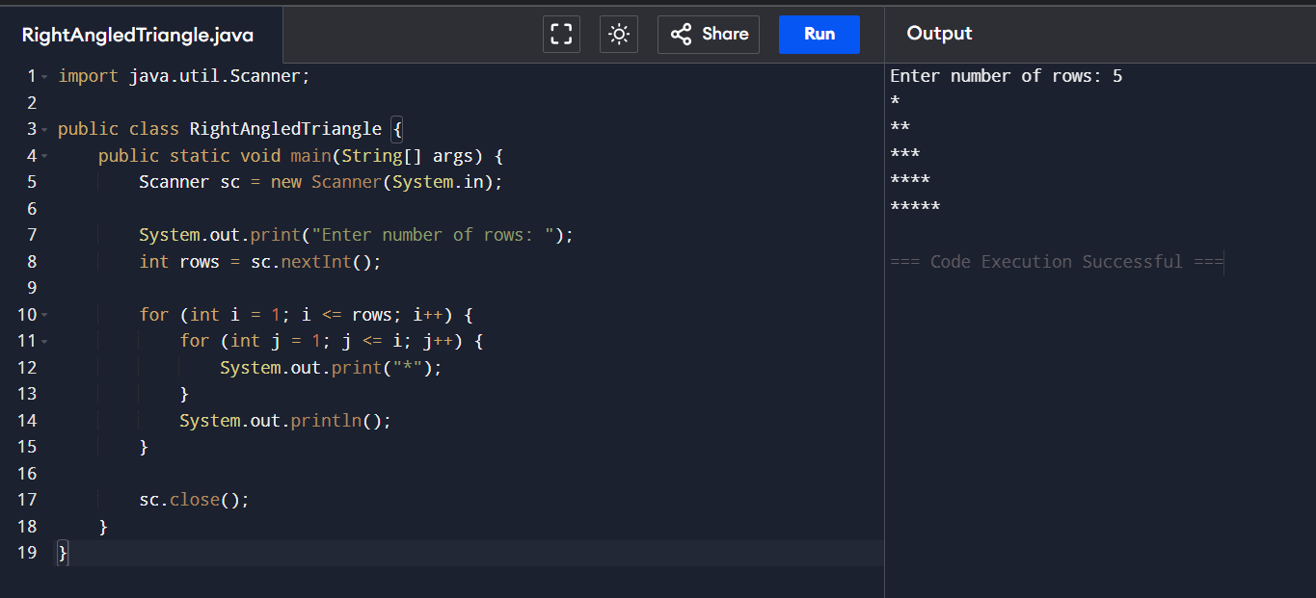
2 .Number Pyramid
🔹 Problem Statement:
Write a java program to print a number pyramid pattern based on the number of rows.
🔹 Sample Output (for 5 rows):
1
1 2
1 2 3
1 2 3 4
1 2 3 4 5
🔹 Java Program:
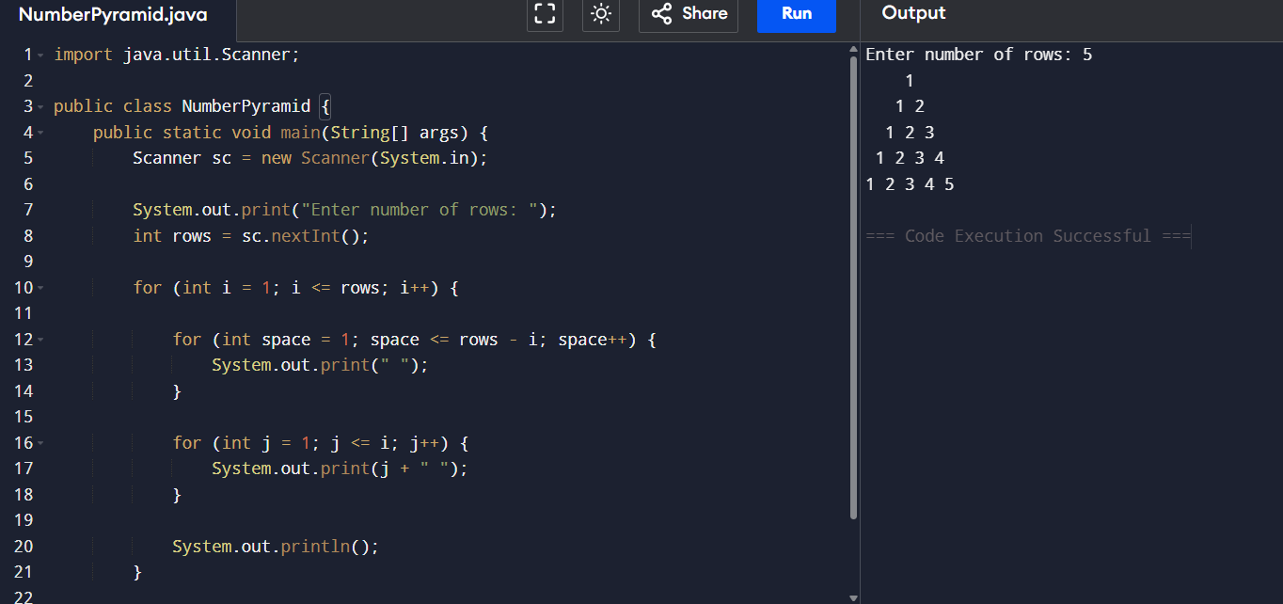

3. Hollow Square Pattern
Sample Output:
*****
* *
* *
* *
*****
Java Program:
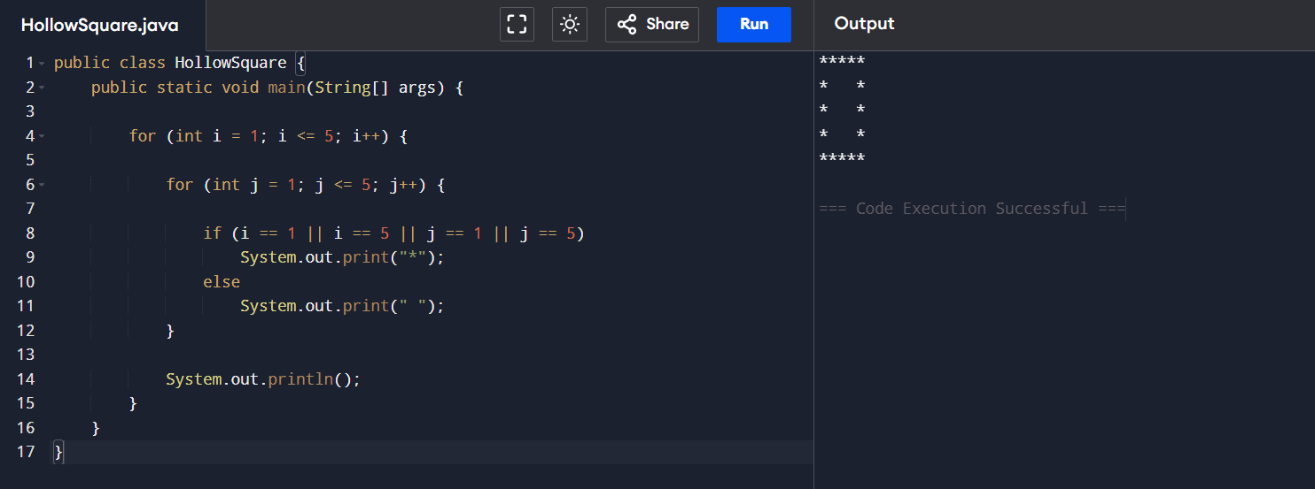

4. Number Right-Angled Triangle
Sample Output:
1
1 2
1 2 3
1 2 3 4
1 2 3 4 5
java Program:
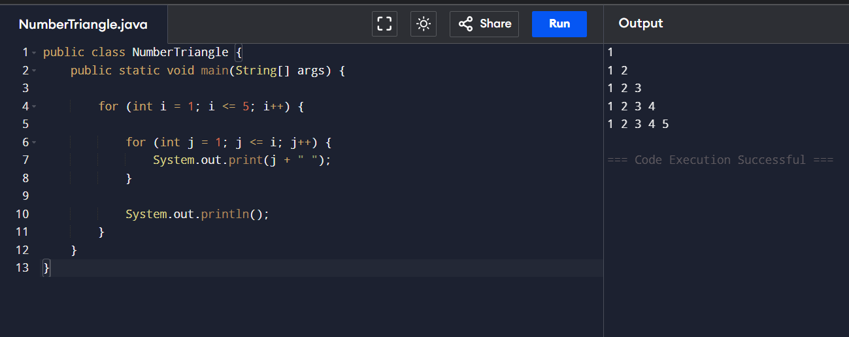

5. Alphabet Triangle Pattern
Sample Output:
A
A B
A B C
A B C D
A B C D E
java Program:
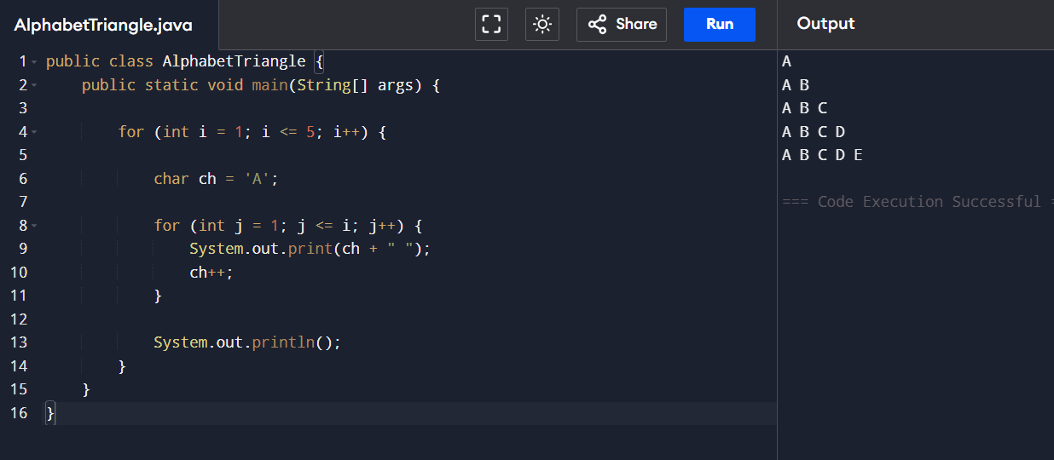

6. Diamond Star Pattern
Sample Output:
*
***
*****
***
*
Java Program:
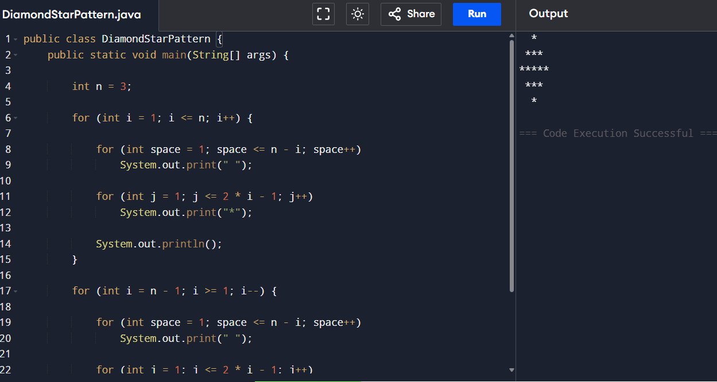

7. Floyd’s Triangle
Sample Output:
1
2 3
4 5 6
7 8 9 10
11 12 13 14 15
java Program:
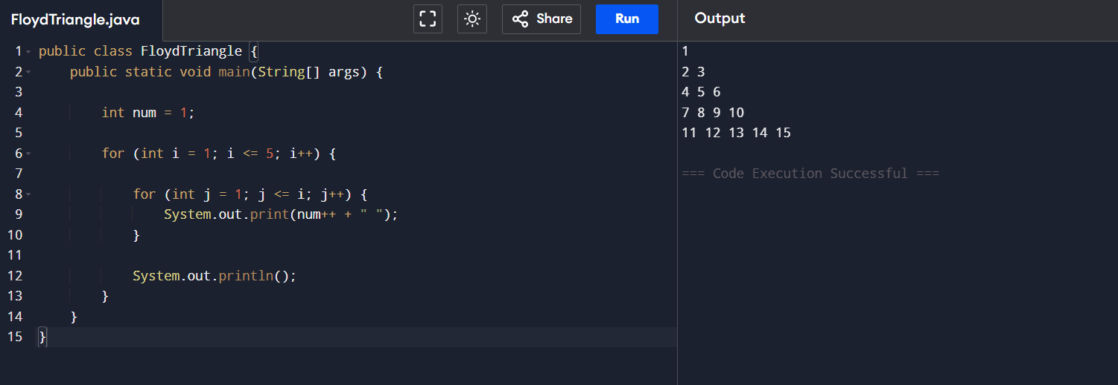

8. Right-Aligned Star Triangle
Sample Output:
*
**
***
****
*****
java Program:
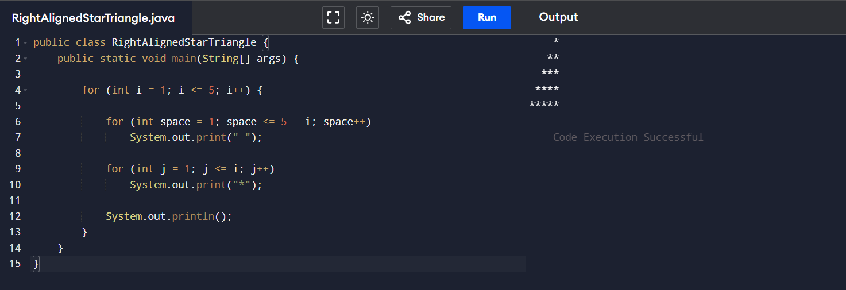

9. Inverted Number Triangle
Sample Output:
1 2 3 4 5
1 2 3 4
1 2 3
1 2
1
Program:
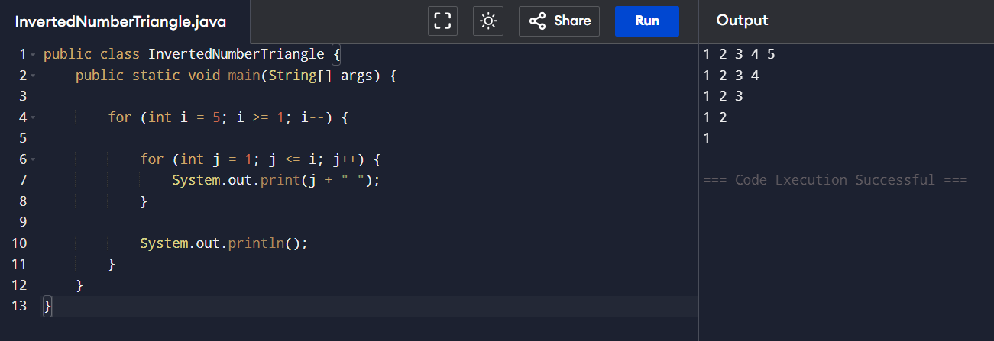

10. Binary Number Triangle
Sample Output:
1
0 1
1 0 1
0 1 0 1
1 0 1 0 1
Program:
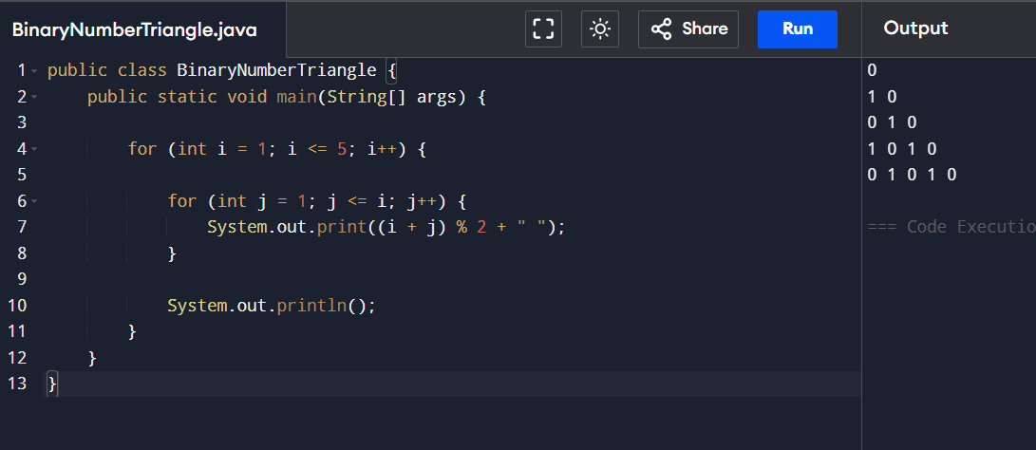

11. Half Diamond Star Pattern
Sample Output:
*
**
***
**
*
Program:
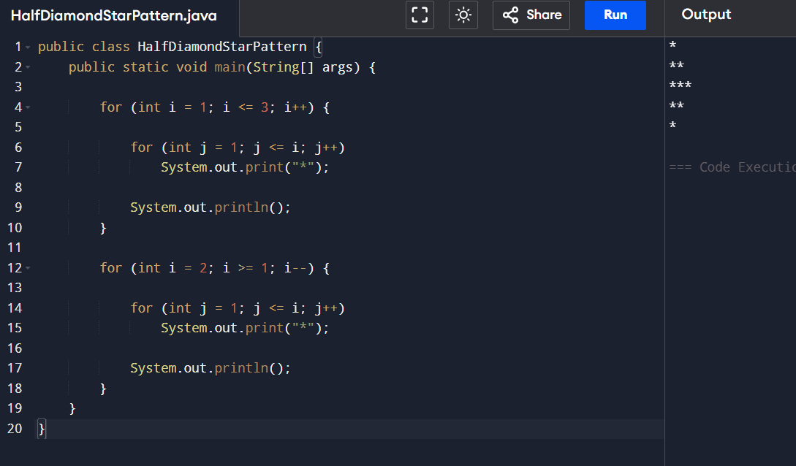

12. Hollow Right-Angled Triangle
Sample Output:
*
**
* *
* *
*****
Program:
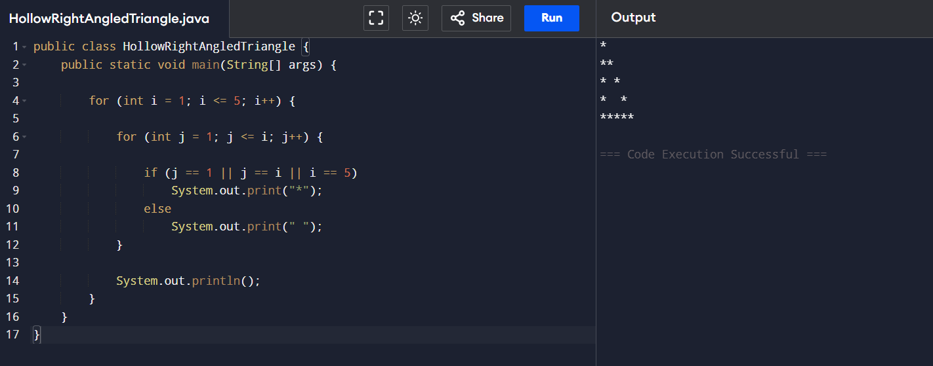

13. Reverse Pyramid of Stars
Sample Output:
*********
*******
*****
***
*
Program:
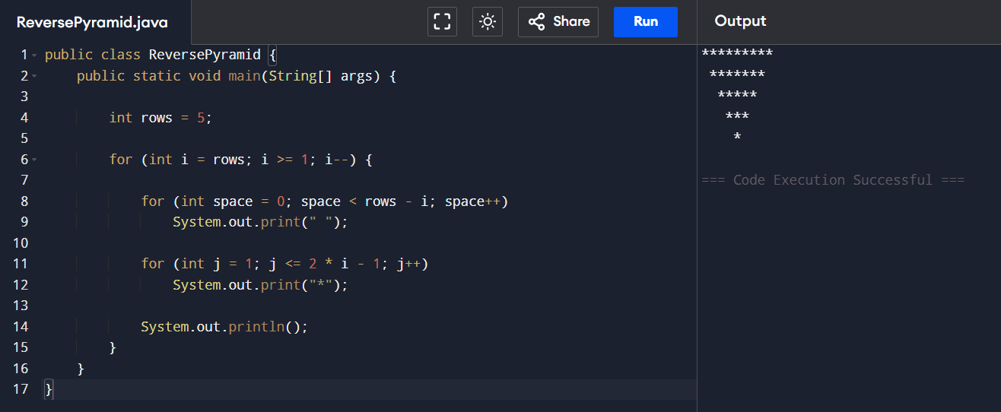

14. Continuous Characters Triangle
Sample Output:
A
B C
D E F
G H I J
K L M N O
Program:
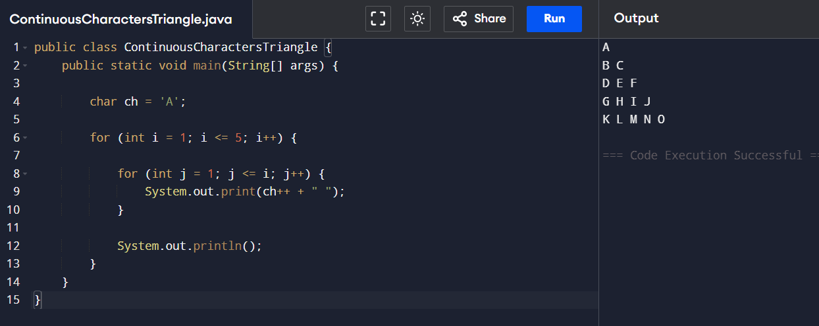

15. Right-Angled Triangle with Even Numbers
Sample Output:
2
2 4
2 4 6
2 4 6 8
2 4 6 8 10
Program:
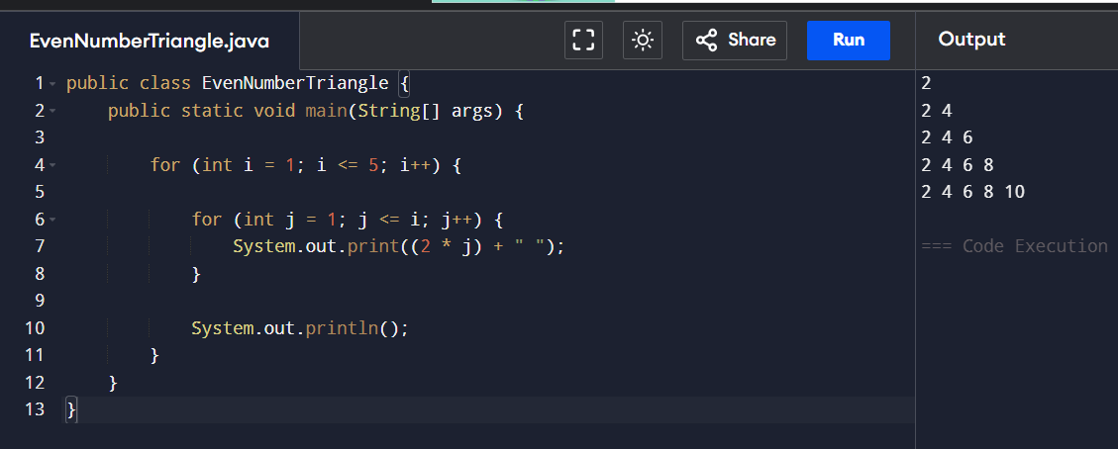

16. Triangle of Odd Numbers
Sample Output:
1
3 5
7 9 11
13 15 17 19
21 23 25 27 29
Program:
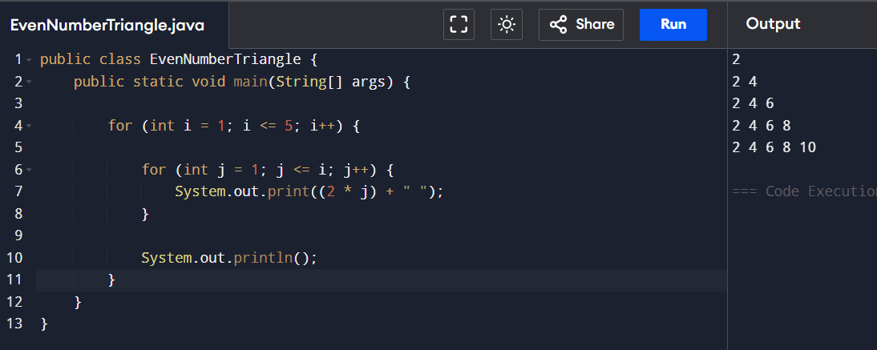

17. Hollow Pyramid Pattern
Sample Output:
*
* *
* *
* *
*********
Java Program:
